In today's rapidly restructuring global industrial chains and profound reshaping of talent standards through technological revolutions, a core proposition for the future is becoming increasingly urgent:
What kind of vocational education system is needed to support the future industrial system?

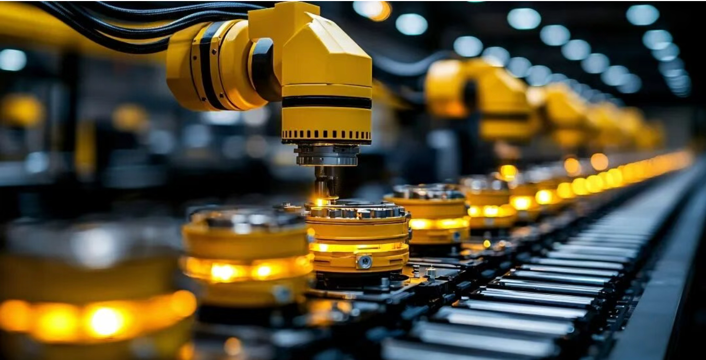

Future International Institute of Vocational Education
To respond to the questions of this era, Youlan International has joined forces with numerous industry elites to create:
Future International Vocational Education Research Institute
Future International Institute of Vocational Education（FIIVE）， It is about to be officially unveiled and established in Shanghai, China.
The research institute will take the strategic orientation of "based on industry, facing the future, and connecting the world", positioning itself as a high-end think tank and a global innovation empowerment platform, and committed to building a hub for deep dialogue between Chinese vocational education and the world.

F I I V E

It is worth noting that the Future International Institute for Vocational Education (FIIVE) has clearly benchmarked the UNESCO International Centre for Vocational Education and Training (UNESCO-UNEVOC) in its strategic architecture and global network construction

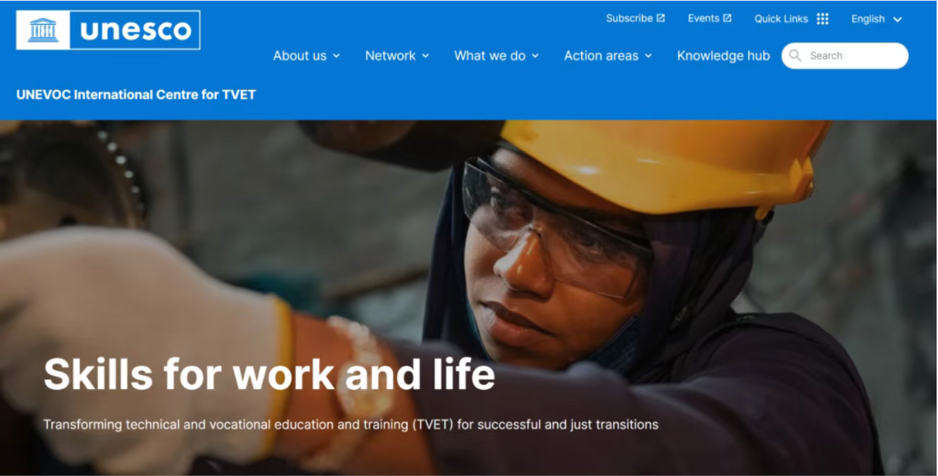

As the most influential multilateral cooperation network in the field of vocational education worldwide, UNESCO-UNEVOC has long been committed to promoting exchanges, mutual learning, and capacity building among member countries' vocational education systems.

F I I V E

Based on the practical accumulation of 18 years of deep cultivation in human resources and vocational education by Youlan International and Tiankun Education Group, and in collaboration with industry elites, we focus on the strategic intersection of "vocational education industry transformation future skills" and systematically layout ten core key areas:
1. Research on vocational education policies and educational standards
2. High end talent cultivation and model innovation
3. Integration of Industry and Education and Construction of Industrial Colleges
4. Research on Digitalization of Vocational Education and Future Skills
5. International vocational education benchmarking and group education empowerment
6. Professional cluster construction and curriculum system design
7. Construction of teaching staff and cultivation of renowned teachers and craftsmen
8. Teaching Diagnosis and Evaluation and Quality System Construction
9. Skills Competition Guidance and Training Base Construction
10. Promotion of research and achievement transformation in vocational education projects
From the reconstruction of the curriculum system based on the job competency map, to the prediction of key skills in new quality productivity tracks such as artificial intelligence, low altitude economy, and new energy vehicles, all projects of the research institute have their own "practical genes" and refuse theoretical idleness.

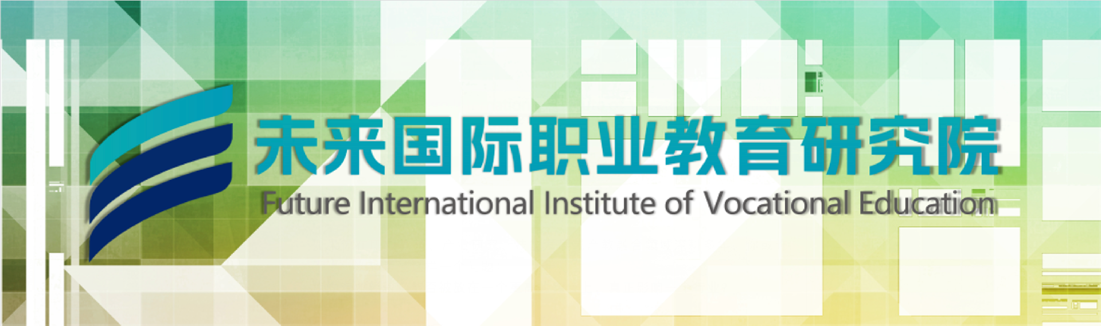

At the core business level, the research institute will cover seven major areas: vocational education research, education consulting, academic exchange, resource docking, curriculum and textbook development, training and teacher development, and project implementation, forming a complete value chain loop from cutting-edge research to practical implementation.
What is particularly prominent is that the research institute adheres to a "results oriented" approach - research results are first verified and iteratively optimized within the group's internal universities, thereby forming replicable and promotable industry benchmarks, truly achieving a virtuous ecology of "research guiding education, education supporting research, and achievements empowering the industry".

Our mission is to gather global vocational and technical education elites, promote innovative paradigms in vocational education through forward-looking research and cross regional cooperation, and provide talent strategic support for the sustainable development of the world's industrial economy. The relevant person in charge of the research institute stated that in the future, the institute will deeply integrate into the global vocational education dialogue network represented by UNESCO-UNEVOC, continue to hold international vocational education forums, industry seminars, and achievement release activities, promote the landing of cross-border vocational education projects, and make Chinese wisdom an indispensable value pivot in the global vocational education reform.

F I I V E

Future International Vocational Education Research Institute (FIIVE)
Not just research, but also leadership.
In the grand narrative of global vocational education and industrial transformation, a new vocational education think tank based in China and connected to the world is poised to take off, waiting for the dual test of time and the times.

