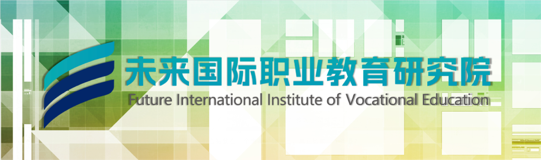
If you have spent years working in the fields of vocational education, industrial research, skill development, or industry-education integration, you may have pondered this question more than once:
Can my professional experience be placed on a higher stage to truly influence an industry?

Now, this opportunity has come

Future International Institute of Vocational Education (FIIVE)

Created by Youlan International in collaboration with numerous industry elites, this high-end think tank and innovation platform, which benchmarks the global network architecture of UNESCO UNESCO-UNEVOC, has officially launched the first round of the "Hundred Expert Think Tank" recruitment plan nationwide.

We are not looking for ordinary participants, we are looking for you among a hundred experts!


Why join us?
This is not a part-time job,
This is an admission ticket for the circle.
Joining the Future International Vocational Education Research Institute (FIIVE) expert think tank, you will not only receive an honorary title, but also enter a high concentration, high potential, and high link expert ecosystem:

01

High end circle deep linking
Engage in dialogue with industry leaders from around the world, broaden the boundaries of your network, and break through the information cocoon. This is the intersection of elites in vocational education, industry, policy, and technology. Every exchange can be a cognitive upgrade.
02

Platform supports personal endorsement
Relying on the strong platform resources of Youlan International and Tiankun International Education Group for 18 years, we provide you with authoritative expert leader honors and brand support. Your professional opinions will be published under the name of "Expert of Future International Vocational Education Research Institute Think Tank", and your personal influence will be multiplied by the full industry chain ecological resource network constructed by the group platform.
03

Global perspective practical implementation
By benchmarking against the UNESCO-UNEVOC Global Vocational Education Dialogue Network, your research findings will have the opportunity to enter the core agenda of cross-border exchanges, policy recommendations, and standard setting. Do not conduct research on paper, only practical results that can be written into policies, courses, and industry scenes!



61 leading experts have already taken their seats, waiting for the expert leader's' you 'in a vacant seat!

At present, the research institute has gathered a group of leading forces that truly stand at the forefront of the industry, covering:
Intelligent manufacturing, industrial robots, CNC machining, new energy vehicles and auto repair, intelligent networking, information technology and network security, electronic information technology, artificial intelligence, drones and low altitude technology, modern finance, modern services, digital commerce and logistics, nursing and health management, cooking and catering services, construction engineering, BIM technology, green low-carbon construction, preschool education and modern education services, digital media and cultural and creative design, new energy and green low-carbon technology, modern agriculture and rural revitalization, and more than ten other technology and service fields. Think tank experts cover the following six categories:

17 national leading experts in high-precision and cutting-edge industries

13 leading experts in the National Core Skills Competition

10 specialized guidance experts for academic competitions

9 leading experts in the specialized studio

7 Chief Experts in Vocational Education Research

5 senior management experts from a first-class technician college

They have already attended.
Among the hundred seats, you are the one waiting for empty seats!

Open your exclusive moment
After strict review by the research institute, you will officially become the "Expert Think Tank Leader of Future International Vocational Education Research Institute" and be invited to attend the unveiling ceremony of the institute's official establishment and the appointment ceremony of think tank experts held in Shanghai recently.
Witness this important moment in the history of vocational education in China with hundreds of outstanding leaders!
A hundred experts, a hundred insights, one circle.
Future International Vocational Education Research Institute - not just for research, but also for leadership.
And you are the key driving force behind this leadership!

Future International Vocational Education Research Institute (FIIVE)
Not just research, but also leadership.
The Future International Vocational Education Research Institute has passed the review and is now publicly soliciting the first batch of 100 qualified outstanding experts from across the country to join the institute's think tank and become the "Future International Vocational Education Research Institute Expert Think Tank Leader". They will share the group's global recognition honors and project achievements, and will be invited to participate in the grand unveiling ceremony of the institute's establishment in Shanghai in the near future. Looking forward to your participation!

Official registration method (choose one of the following three options):
1. Follow the official account of "Youlan International", and send a backstage private message "I want to participate" to get the most timely feedback the next day after the private message is sent;
2. Search for the official website of "Youlan International":
www.youlife.cn， During weekdays, call the official hotline at 021-61736744 to register and participate;
3. Scan the QR code below and add a note saying 'I want to participate' when contacting to add WeChat. After the review is approved, contact the research institute teacher on WeChat to report
Name.

